Product Specification

**Breakout PCB Using DRV8243 with SPI Control**

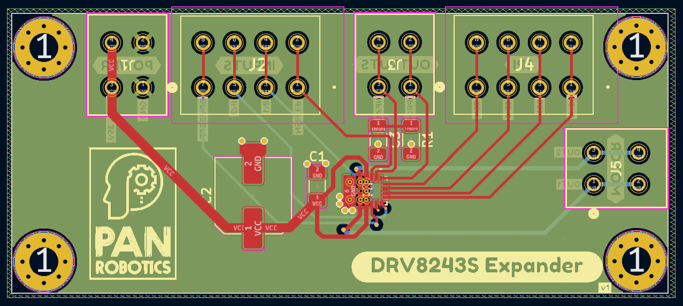

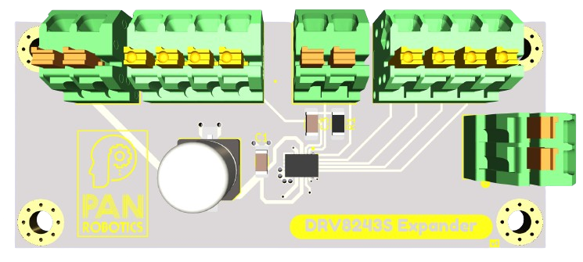

**Overview:** This document provides the product specifications for the DRV8243 breakout PCB designed for robust control of DC motors. Capped at a 3A current output and featuring an SPI communication interface, this PCB is ideal for a wide range of applications demanding precision and efficiency.

**Key Features:**

* Integrated DRV8243-Q1 motor driver IC.
* 3A continuous current output.
* SPI communication interface for advanced control.
* Over current, over temperature, and under voltage lockout protection.
* Compact and highly reliable design.

**Applications:** Suitable for various automotive and industrial applications such as robotic arms, automated guides, and actuation systems requiring precise motor control.

**Marketing Information:** Our DRV8243 breakout PCB stands out in the market for its integration of advanced control features with the simplicity of a breakout board. Its SPI interface allows for detailed performance tuning, making it a go-to solution for developers and engineers alike.

**Product Specifications:** The PCB is built around the DRV8243-Q1, providing a peak current output of 3A with a wide operating voltage range, detailed diagnostic capabilities, and a versatile SPI communication protocol.

**Additional Details:** For detailed connection diagrams, pin configurations, and technical specifications, please refer to the attached schematic and 3D model images provided within this document.

